|  |  |  |
| --- | --- | --- |
|  | DISPLAY SYSTEM DATE AND TIME |  |
| Exp No.: 11 |  | **Name:** S Vishakan |
| Date: 14-10-2020 |  | **Reg. No:** 18 5001 196 |

**AIM:**

To write assembly language programs to perform the following system operations:

1. Display System Date
2. Display System Time

**PROGRAM – 1: SYSTEM DATE:**

**ALGORITHM:**

1. Begin.
2. Declare the data segment.
3. Initialize data segment with variables to store day, month and year.
4. Close the data segment.
5. Declare the code segment.
6. Set a preferred offset (preferably 100h)
7. Load the data segment content into AX register.
8. Transfer the contents of AX register to DS register.
9. Load 2Ah to AH register. (DOS function to obtain system date)
10. Call interrupt 21h to service the DOS function.
11. Load the offset address of variable ‘day’ to SI.
12. Transfer contents of DL register through SI to variable ‘day’.
13. Load the offset address of variable ‘month’ to SI.
14. Transfer contents of DH register through SI to variable ‘month’.
15. Load the offset address of variable ‘year’ to SI.
16. Transfer contents of CX register through SI to variable ‘year’.
17. Introduce an interrupt for safe exit. (INT 21h)
18. Close the code segment.
19. End.

|  |  |
| --- | --- |
| **PROGRAM** | **COMMENTS** |
| assume cs:code, ds:data | Declare code and data segment. |
|  |  |
| data segment | Initialize data segment with values. |
| day db 01 dup(?) | Variable to store day. |
| month db 01 dup(?) | Variable to store month. |
| year db 02 dup(?) | Variable to store year. |
| data ends |  |
|  |  |
| code segment | Start the code segment. |
| org 0100h | Initialize an offset address. |
| start: mov ax, data | Transfer data from “data” to AX. |
| mov ds, ax | Transfer data from memory location AX to DS. |
|  |  |
| mov ah, 2Ah | Load 2Ah to AH (DOS code for system date function) |
| int 21h | Interrupt DOS with 21h to get the system date. |
| mov si, offset day | Load offset of variable ‘day’ to SI. |
| mov [si], dl | Copy to ‘day’ the value of DL through SI. |
| mov si, offset month | Load offset of variable ‘month’ to SI. |
| mov [si], dh | Copy to ‘month’ the value of DH through SI. |
| mov si, offset year | Load offset of variable ‘year’ to SI. |
| mov [si], cx | Copy to ‘year’ the value of CX through SI. |
|  |  |
| mov ah, 4ch |  |
| int 21h | Interrupt the process with return code and exit. |
| code ends |  |
| end start |  |

**UNASSEMBLED CODE:**

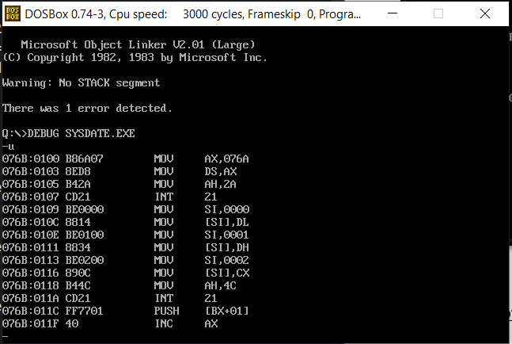

**SAMPLE I/O SNAPSHOT:**

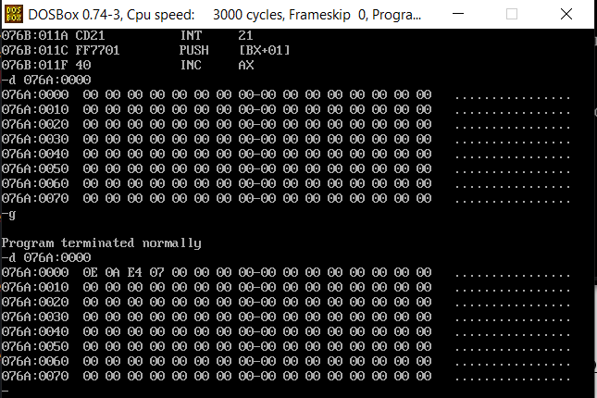

**PROGRAM – 2: SYSTEM TIME:**

**ALGORITHM:**

1. Begin.
2. Declare the data segment.
3. Initialize data segment with variables to store hour, minute and second.
4. Close the data segment.
5. Declare the code segment.
6. Set a preferred offset (preferably 100h)
7. Load the data segment content into AX register.
8. Transfer the contents of AX register to DS register.
9. Load 2Ch to AH register. (DOS function to obtain system time)
10. Call interrupt 21h to service the DOS function.
11. Load the offset address of variable ‘hour’ to SI.
12. Transfer contents of CH register through SI to variable ‘hour’.
13. Load the offset address of variable ‘minute’ to SI.
14. Transfer contents of CL register through SI to variable ‘minute’.
15. Load the offset address of variable ‘second’ to SI.
16. Transfer contents of DH register through SI to variable ‘second’.
17. Introduce an interrupt for safe exit. (INT 21h)
18. Close the code segment.
19. End.

|  |  |
| --- | --- |
| **PROGRAM** | **COMMENTS** |
| assume cs:code, ds:data | Declare code and data segment. |
|  |  |
| data segment | Initialize data segment with values. |
| hour db 01 dup(?) | Variable to store hour. |
| minute db 01 dup(?) | Variable to store minute. |
| second db 02 dup(?) | Variable to store second. |
| data ends |  |
|  |  |
| code segment | Start the code segment. |
| org 0100h | Initialize an offset address. |
| start: mov ax, data | Transfer data from “data” to AX. |
| mov ds, ax | Transfer data from memory location AX to DS. |
|  |  |
| mov ah, 2Ch | Load 2Ch to AH (DOS code for system time function) |
| int 21h | Interrupt DOS with 21h to get the system time. |
| mov si, offset hour | Load offset of variable ‘hour’ to SI. |
| mov [si], ch | Copy to ‘hour’ the value of CH through SI. |
| mov si, offset minute | Load offset of variable ‘minute’ to SI. |
| mov [si], cl | Copy to ‘minute’ the value of CL through SI. |
| mov si, offset second | Load offset of variable ‘second’ to SI. |
| mov [si], dh | Copy to ‘second’ the value of DH through SI. |
|  |  |
| mov ah, 4ch |  |
| int 21h | Interrupt the process with return code and exit. |
| code ends |  |
| end start |  |

**UNASSEMBLED CODE:**

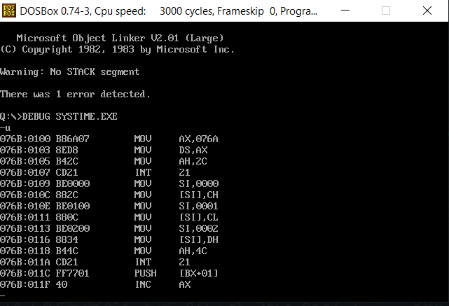

**SAMPLE I/O SNAPSHOT:**

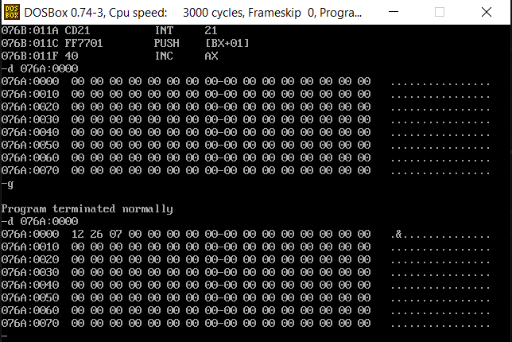

**RESULT:**

The assembly level programs were written to perform the above specified system operations, namely, system date and system time and the output was verified.